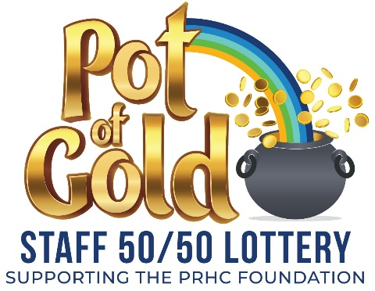
Withdrawal Form
To cancel your participation in the PRHC Foundation Pot of Gold Staff 50/50 Lottery, please complete the form below and return it to the PRHC Foundation. If you want to reduce the number of tickets you hold in the Lottery but not cancel completely, you must complete the Change Form.

I want to cancel my participation in the Lottery:
Please fill in all fields to ensure we can process your application.
Name: Employee ID#:
Can be found on your Informe profile

Department: Work Phone/Ext:
Home Address:
City: Prov: Postal Code:
Home Phone: Email:

Yes! I'd like to receive the latest email updates from the PRHC Foundation about how my support makes great care possible at PRHC.

By signing this form, I authorize my bi-weekly pay deductions for the PRHC Foundation Pot of Gold Staff 50/50 Lottery to be discontinued. Enrollments and cancellations must be submitted to PRHC Foundation. Once the form is received, it will be submitted to Payroll for processing for the upcoming payroll cycle. Participants who have cancelled will be kept in the draw until Payroll has processed their cancellation and the participant is no longer eligible. If a participant’s name is included in any draw, they are not eligible for refund on that draw. Terms & Conditions are available on the back of this form, by calling the PRHC Foundation at 705-876-5000, or online at https://prhcfoundation.ca/ways-to-give/staff-giving/. Please note Lottery participation is not considered a donation by Canada Revenue Agency and is therefore not eligible for a charitable donation receipt. Should the regularly scheduled draw date fall on a day that the Foundation office is closed, an alternate draw date within the same week will be selected with pre-approval from municipal lottery officials.
I wish to have my name removed completely from the Pot of Gold Staff 50/50 Lottery. I understand that once the Withdrawal Form is received, it will be submitted to Payroll for processing for the upcoming payroll cycle. I also understand that should I choose to resume play, I will be accommodated on a first-come, first-served basis, as tickets are available, and may be placed on a waiting list.

Signature: Date:

Please submit your completed form to the PRHC Foundation:
Mail or In Person: PRHC Foundation Office - W4770 Fax: 705-876-5032
1 Hospital Drive, Peterborough, ON K9J 7C6 E-mail: donations@prhc.on.ca

For more information, visit https://prhcfoundation.ca/ways-to-give/staff-giving/ or call 705-876-5000.

Lottery License # M869230

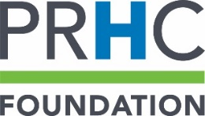
Terms & Conditions
Lottery license # M869230
- Peterborough Regional Health Centre (PRHC) will facilitate bi-weekly Payroll deductions for employees enrolled in the voluntary Staff Lottery. A staff member must have been paid during the pay period in question in order for a deduction to be made and to be eligible for the corresponding Lottery draw.
- PRHC physicians and registered volunteers are eligible to participate in the Staff Lottery by purchasing tickets from the PRHC Foundation with a cheque for the amount equal to the entirety of the gaming period. Payment must be renewed in advance of each gaming period, or enrollment will be cancelled.
- Participants must be 18 years of age or older.
- Tickets will be available on a first come, first served basis. A waiting list will be maintained for people who wish to enter the draw and they will be offered tickets as they become available.
- A maximum of 2,500 tickets will be printed per draw.
- A maximum of six (6) tickets per draw per individual can be purchased.
- Participants who are already enrolled in the Lottery may add or remove tickets by submitting a Change Form to PRHC Foundation. Once the form is received, it will be submitted to Payroll for processing for the upcoming payroll cycle. Tickets will be available on a first come, first served basis. If no tickets are available, the participant will be added to the waiting list and tickets awarded when available.
- Participants who wish to withdraw from the Lottery are able to do so by submitting a Withdrawal Form available on the PRHC Foundation website (https://prhcfoundation.ca/ways-to-give/staff-giving/), PRHC intranet or at the Foundation office, or by notifying the Foundation by email at donations@prhc.on.ca. Once the Withdrawal Form is received, it will be submitted to Payroll for processing for the upcoming payroll cycle. To resume play, individuals must submit a new Enrollment Form and will be awarded tickets on a first come, first served basis as available.
- In the case that an employee is enrolled in the Lottery and does not have sufficient funds in their pay to be deducted for the Staff Lottery, they will NOT be eligible for that particular draw.
- Staff members who have not paid through Payroll deduction for three (3) consecutive pay periods will be automatically withdrawn from the Lottery in its entirety.
- PRHC staff members, physicians or volunteers who have retired, resigned or been terminated will no longer be eligible to be in the draw.
- If a ticket is drawn and the winner is determined to be ineligible (due to insufficient funds, NSF cheque, resignation, retirement, termination, leave of absence, unpaid vacation, etc.), the ticket in question will considered ineligible to win and a new ticket will be drawn.
- PRHC Foundation employees, office volunteers, Foundation board members, and the hospital Payroll staff, will not be eligible to participate in the Staff Lottery.
- All personal information for Lottery participants will be entered into the PRHC Foundation’s database and will be treated as confidential.
- Draws will be conducted on the Wednesday after each pay day at 1:00 pm at the PRHC Foundation office at 1 Hospital Drive, Peterborough, ON K9J 7C6. Should the regularly scheduled draw date fall on a day that the Foundation office is closed, an alternate draw date within the same week will be selected with pre-approval from municipal lottery officials.
- Actual prize amount varies with total number of tickets sold. Fifty percent of all monies received for the bi-weekly draw will be awarded to the winner.
- Winners will be notified by a PRHC Foundation representative by phone and/or email no later than 4:00 pm on the day following the draw date (1 Hospital Drive, Peterborough). A cheque in the name of the winner will be issued as soon as possible, subject to the availability of signing officers of the PRHC Foundation corporation.
- The PRHC Foundation will send an All User Email sharing the name of the winner, prize value, and photo of the winner if available, no later than 4:00 pm on the day following the draw date.
- Winners will also be posted on PRHC’s intranet and on the PRHC Foundation’s website (https://prhcfoundation.ca/ways-to-give/staff-giving/) no later than 4:00 pm on the day following the draw date.
- Should you be a winner, your signature on the Enrollment or Change forms gives consent for the PRHC Foundation to post your name, photo and/or video footage on the PRHC Foundation website, PRHC Intranet, and in PRHC All User Emails.

